**Master Functional Document**

|  |  |
| --- | --- |
| **Application** | NGERP - Centra |
| **Service Bundle** | Master Management |
| **Service Request** | GL Category |

**Description:**

GL Category in Compiere (NGERP - Centra) organizes journal entries into groups for easier tracking and reporting. It allows users to define categories for manual, imported, or system-generated journals. Each category can be linked to a company, branch, and a source type for better control.

**Workflow Process:**

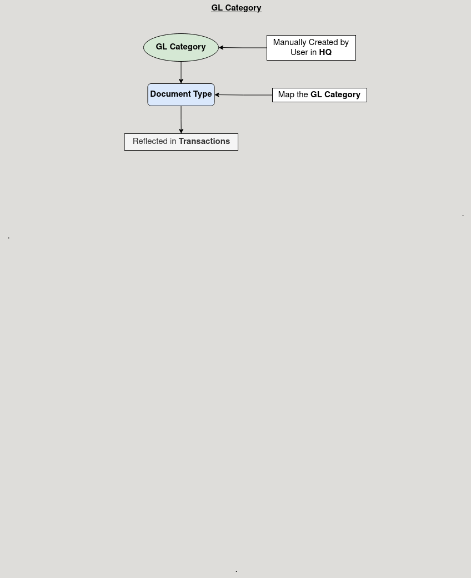

**Business Rules:**

* It is visible in both **HQ** and **ROW.**
* C**reation** is possible only in **HQ.**
* Active status makes the category available for use in journal entries.
* Category Type indicates the source of the journal (e.g., document, manual, import).
* Default option marks the category as the default for journal entries.
* Description is optional, providing extra details about the category.
* Each company or branch can have its own set of categories for better organization.